xpedx.com Next generation
Order Holds in Call Center Design Document

Authors: Sterling Commerce

Date Created: 01/03/10
Last Updated: 07/01 /10
File Name: C:\Documents and Settings\bfurman\My Documents\Temp\Methodology v1.1\Project Management\TEMPLATE - DOCUMENT - Use Case Definition.doc0000.doc

Approval Signatures (Mandatory)

Title | Name | Signature | Date | Comments / Issues / Concerns
xpedx Owner(s) | Steve Bugher
xpedx Owner(s) | Cheryl Tullis
Sterling Commerce Owner(s) | Guy Read

Note: The sign off indicates approval of all sections of the document.

Document Revision History

This chart tracks the changes introduced by the revisions to the document as the project progresses through the stages of the System Development Life Cycle (SDLC).

Version | Date | Description (Changes Made) | Author(s)
1.0 | 03/01/2010 | Initial Draft | Sterling
2.0 | 03/04/2010 | Ready to Deliver | Sterling
3.0 | 4/29/2010 | Updated by Guy Read to send | Sterling
4.0 | 06/23/2010 | Incorporated review comments by xpedx | Sterling
5.0 | 06/30/2010 | Incorporate review comments by xpedx | Sterling
6.0 | 07/01/2010 | Added column - Web Channel to rule tables | Sterling
7.0 | 07/01/2010 | Feedback incorporated by Sterling | Sterling
8.0 | 07/01/2010 | Add two new rules | Sterling

Related or Reference Documents

Document Name | Description | Owner | Location
SCI_Xpedx Solution Definition Document v1.5 | Solution Definition document | Sterling Commerce
07.19_Transact_and_Fulfill_Order_Dashboard_V1.0.doc | Functional Process and Feature Identification document | Xpedx
11.01_B2B_BusinessRules_V3.0.doc | Functional Process and Feature Identification document | Xpedx

TABLE OF CONTENTS

1. Introduction 5
1.1 Document Purpose 5
1.2 Document Audience 5
2 Order Holds 6
2.1 Overview 6
2.2 Master System 7
2.3 Process Flow 7
2.3.1 Order Hold Flow 7
2.3.2 Flow Details 8
2.4 Order Hold Rules 9
2.4.1 Order Hold Resolution 9
2.4.2 Rule Definition 11
2.5 Screen Shots 16
2.6 Open Questions 17
2.7 Assumptions 17
3 Glossary 17

Introduction

Document Purpose

This document is the governing design document which outlines why an order, B2B or interactive, goes on hold on the Sterling system. It also outlines how the hold should be resolved on the Sterling Call Center. Testing, builds, configuration management are not covered in this document.

The document will also serve the purpose of keeping a list of assumptions that were made during design discussions.

Document Audience

This document is intended for management and technical staff working on this project, xpedx IT and Business, Web methods, Legacy(MAX and ACCESS), HP, IW, xpedx/IP Network Team. Sterling will use the document during design and configuration for design consideration.

Order Holds

Overview

A B2B order or an interactive order will go into hold on the Sterling system if the system deems that the order needs to be updated manually before it can be dispatched to the fulfillment systems. The system will maintain a list of rules governing order holds. Any incoming order will be evaluated against these rules to determine if it should be placed on hold. If the order passes all the rules, it will flow to the fulfillment systems. If it fails it will go on hold on the Sterling system.

A Customer Service Representative (CSR) can query the system to find orders which are on hold using the Sterling Call Center. The Sterling Call Center will highlight the details on the order which caused the order to fail validation. The CSR can use the Sterling Call Center to update the order manually and reevaluate the order against the order hold rules. Once the order passes all the rules, the CSR will be able to place the order on the fulfillment systems.

xpedx maintains a master set of rules. The subset of these rules which is applicable to a particular customer is set up in the customer profile. This rules maintenance page is visible to internal users only. The specifics of the user group which can access the rules maintenance screens for a customer are outlined in xpedx Security Detailed Design.

The original version of the order as in came into Sterling system will be recorded for reference.

Master System
The Sterling system is the system of record for all order rules defined in Sterling.

Process Flow

Order Hold Flow
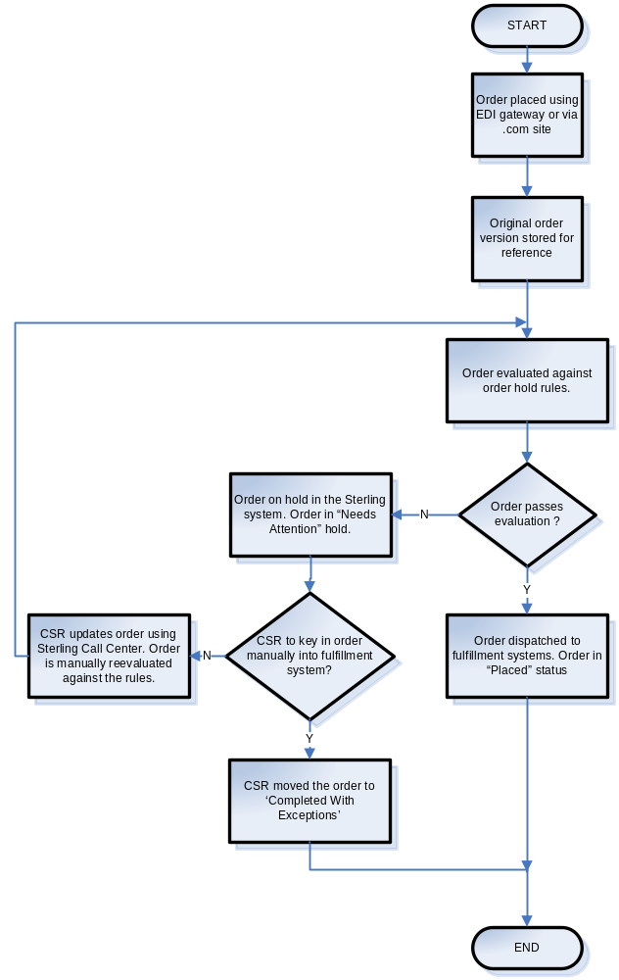

Flow Details
- All B2B orders and interactive orders will pass through the Sterling system before being sent to the fulfillment systems.
- The initial version of the order, both B2B and interactive, will be stored in the Sterling system for reference. The Sterling Call Center will allow viewing of the initial version of the order.
- Order hold rules will be maintained against the customer profile.
- The order will be evaluated against the order hold rules.
- If an order passes all the rules, it will flow to the fulfillment systems. Once an order is dispatched the fulfillment system(s), it will move to “Placed” status.
- If an order fails the validation rules, it will be put on “Needs Attention” hold. An email will be sent to the CSR of the division handling the order informing him/her that the order is in the ‘Needs Attention’ status. There will be one email per order.
- The CSR can mark an order in “Needs Attention” hold as “Completed With Exceptions” and key in the order manually in the fulfillment systems.
- Evaluation of an order against the order hold rules will happen automatically when the order is placed in the Sterling system. The evaluation can also be triggered manually by the CSR for an order on “Needs Attention” hold after he corrects the issues which caused the order to fail when validated against the hold rules.

Order Hold Rules

Order hold rules are defined on the customer profile. All Customer Accounts and Ship Tos inherit the hold rules defined at the customer profile. The sterling system will provide a screen for administering the order hold rules at the customer profile.

A Ship To can override the rules which are defined by its parent Ship To or Customer Account. The Ship To can choose to inherit the rules from its parent or define the entire set of rules.

The order hold rules are applied against a B2B order once they are created in the system. Similarly they are applied to an interactive order once the Check Out process is completed.

All the rules configured for a customer are applied to all orders created for the customer, B2B as well as interactive unless they are marked as B2B specific.

Order Hold Resolution

The CSR can query any order which goes on hold on the Sterling system using the Sterling Call Center. The CSR can query for all orders which are on “Needs Attention” hold to obtain this list.

The CSR can narrow his search results using the following search criteria on the Call Center –

- Web Confirmation #
- Legacy Order #
- Customer Division
- Customer Name
- Customer Account Name
- Customer Account #
- eTrading ID
- Customer PO #
- From Status (range for order line status since status is maintained at the line-quantity level in Sterling)
- To Status (range for order line status since status is maintained at the line-quantity level in Sterling)
- Start Date (range for order creation date)
- End Date (range for order creation date)
- Master Customer Name
- Need Attention (checkbox)

This will give the CSR a list of all orders which are on hold on the Sterling system.
The following fields will be displayed on the list page on the Call Center –

- Customer Division
- Customer Account Name
- Customer PO#
- eTrading ID
- Order Total
- Last Modified Date
- User who made the last modification

The CSR will then navigate to the individual order detail screen to view the validation errors.

The Call Center order detail screen will list all violations of the order hold rules. The order detail panel will list all rules which failed at the order level.

The CSR will update the order details and click on “Update Order” to manually invoke the order validation process once he is convinced that all validation errors have been resolved. If the order passes validation against all the applicable rules, the “Place Order” button will be enabled. Clicking on “Place Order” will place the order in the fulfillment systems.

Rule Definition

Business Rules:

Rule | Description | Web Chanel | B2B Specific | Steps To Resolve Hold | Implementation Details
Accept price override | This is a preference. When enabled, it does not exception orders which have lines which specify a price which is different from that returned by P&A call. | N/A | Y | N/A | /Customer/Extn/XpxCustomerRulesProfileList/XpxCustomerRulesProfile  has an entry for the corresponding rule.
Prevent orders from being placed automatically on ordering system. | Option is enabled. All orders would be put on Needs Attention hold. | Hold | N | CSR can resolve the hold by checking the override option on the Order Dashboard. | /Customer/Extn/XpxCustomerRulesProfileList/XpxCustomerRulesProfile  has an entry for the corresponding rule.

Order Rules:

Rule | Description | Web Channel | B2B Specific | Steps To Resolve Hold | Implementation Details
Header comments were sent by customer | Orders with header comments are placed in the legacy system with the Web Hold Flag set to Y. Order would finally move to the Web Hold status. | Web Hold | N | CSR can resolve the hold by checking the override option on the Order Dashboard | /Order/Intructions/Instruction[@InstructionType=’HEADER_COMMENTS’]/@InstructionText is not null.
Do not allow duplicate POs | Option is enabled; PO # on incoming order is the same as that in an earlier unpurged order already placed in the Sterling system. | Hold | N | CSR can resolve the hold by checking the override option on the Order Dashboard. | getOrderList with /Order/@CustomerPONo populated with the value of /Order/@CustomerPONo present in the order returns records.
Non-Standard ship method | Option is enabled and the ship method specified on order is not ‘STANDARD’. | Hold | N | CSR can resolve the hold by checking the override option on the Order Dashboard. | /Order/@CarrierServiceCode != ‘STANDARD’
Customer selected ship complete | The order has Ship Complete flag set to Y. This preference would force execution of rule – Prevent Backorders | N/A | Y | CSR can resolve the hold by checking the override option on the Order Dashboard. | /Order/Extn/@ExtnShipComplete is set to Y and /Customer/Extn/@ExtnShipComplete is set to Y.
Validate ship-to zip code | Option is enabled and ship-to zip code on the order does not match the ship-to zip code stored against the customer account. | N/A | Y | CSR can resolve the hold by checking the override option on the Order Dashboard.  The CSR would also update the zipcode for the account on the legacy system. | /Order/PersonInfoShipTo/@ZipCode on the order is compared with /Customer/BuyerOrganization/CorporatePersonInfo/@Zipcode
Ship date not next business day | Option is enabled and Ship date specified on the incoming order is not the business day. Eg Ship Date specified is 4 days from the current date. | Hold | N | CSR can resolve the hold by checking the override option on the Order Dashboard. | /Order/@ReqShipDate is not SYSDATE + 1.
Incorrect Buyer ID | Buyer organization code cannot be determined | N/A | Y | Trigger workflow to initiate Buyer ID upload to the .com. Reprocess the order after the Buyer ID has been uploaded to the Sterling system.  This error will show up on exception console and NOT on the order dashboard. The connectivity team will query the exception console for exceptioned orders.  The exception will also show up as an alert when the concerned user logs into the Sterling Call Center. | /Order/@BuyerOrganizationCode is an invalid organization code.
Incorrect eTrading ID | Buyer account cannot be determined | N/A | Y | If the eTrading ID is wrong on the inbound order, CSR can update the eTrading ID (referring to customer account/ship-to maintenance) and reprocess the order.  If the eTrading ID is wrong on the customer account/ship-to maintenance then customer solutions / integration team needs to be involved to update the eTrading ID in customer profile and the order can bed reprocessed.  This error will show up on exception console and NOT on the order dashboard.  The exception will also show up as an alert when the concerned user logs into the Sterling Call Center. | /Order/Extn/@ExtnETradingID does not resolve to a Ship To.

Order Line Rules:

Rule | Reasons For Order Hold | Web  Channel | B2B Specific | Steps To Resolve Hold |  | Implementation Details
Line comments were sent by customer | Orders with line comments are placed in the legacy system with the Web Hold Flag set to Y. Order would finally move to the Web Hold status. | Hold | N | CSR can resolve the hold by checking the override option on the Order Dashboard |  | /Order/OrderLines/OrderLine/Instructions/Instruction[@InstructionType=’LINE_COMMENT’]/@InstructionText is not null.
Require customer line PO | Option is enabled and order line does not specify a PO #. | UI  enforce | N | Update the order line with valid PO #. |  | /Order/@CustomerPONo is null
Require customer line sequence Number | Option is enabled and order line does not specify a PO #. | UI  enforce | N | Update the order line to specify line level field. |  | TBD
Require customer line account number | Option is enabled and order line does not specify a PO #. | UI  enforce | N | Update the order line to specify line level field. |  | TBD
Require customer line field – 1 | Option is enabled and line level field with the specified name is not present in the incoming order. | UI  Enforce | N | Update the order line to specify line level field. |  | /Order/OrderLines/OrderLine/Instructions/Instruction[@InsstructionType = <Customer_Line_Field_1>] is not present where
Require customer line field – 2 | Option is enabled and line level field with the specified name is not present in the incoming order. | UI  Enforce | N | Update the order line to specify line level field. |  | /Order/OrderLines/OrderLine/Instructions/Instruction[@InsstructionType = <Customer_Line_Field_2>] is not present where
Require customer line field – 3 | Option is enabled and line level field with the specified name is not present in the incoming order. | UI  Enforce | N | Update the order line to specify line level field. |  | /Order/OrderLines/OrderLine/Instructions/Instruction[@InsstructionType = <Customer_Line_Field_3>] is not present where
All Requested Line Delivery Dates do not match | Option is enabled; the requested delivery dates on the order lines do not match. | N/A | Y | Update the Requested Line Delivery Date on order lines. |  | /Order/OrderLines/OrderLine/@ReqDeliveryDate is not the same on all lines of the order.
Prevent back orders | Option is enabled | N/A | Y | CSR can resolve the hold by checking the override option on the Order Dashboard. |  | /Item/Extn/@ExtnItemType = ‘STOCK’  AND  /Order/OrderLines/OrderLine/@OrderedQty is less than sum of /PriceAndAvailability/Items/Item/WarehouseLocationList/WarehouseLocation/AvailableQty/text()
Items not available for next day shipment | Option is enabled | Hold | N | CSR can resolve the hold by checking the override option on the Order Dashboard. |  | /Item/Extn/@ExtnItemType = ‘STOCK’  AND  /PriceAndAvailability/Items/Item/WarehouseLocationList/WarehouseLocation[NumberOfDays/text()=0 || NumberOfDays/text()=1]/AvailableQty/text() is less than /Order/OrderLines/OrderLine/@OrderedQty
Price discrepancy | Option is enabled | N/A | Y | CSR can resolve the hold by checking the override option on the Order Dashboard. | (/Order/OrderLines/OrderLine/LinePriceInfo/@UnitPrice - /PriceAndAvailability/Items/Item/UnitPrice/text() ) / /PriceAndAvailability/Items/Item/UnitPrice/text() x 100 is greater than /Customer/Extn/XpxCustomerRulesProfileList/XpxCustomerRulesProfile/@Param1 for the corresponding rule.

Screen Shots

Example Order Search Screen in Sterling Call Center

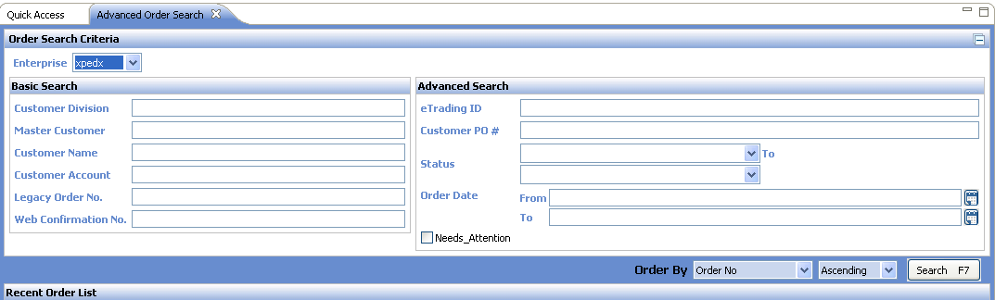

Example Order List Screen on Sterling Call Center

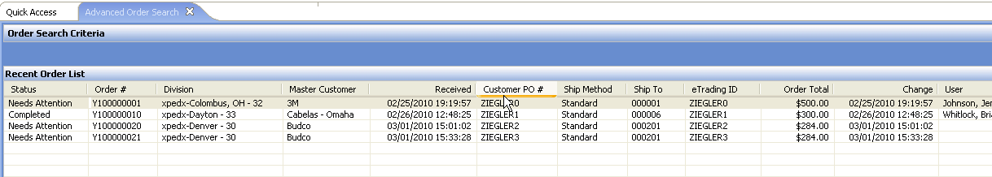

The CSR will click on the desired order on the order list screen to navigate to the order detail screen.

Example Order Detail Screen on Sterling Call Center

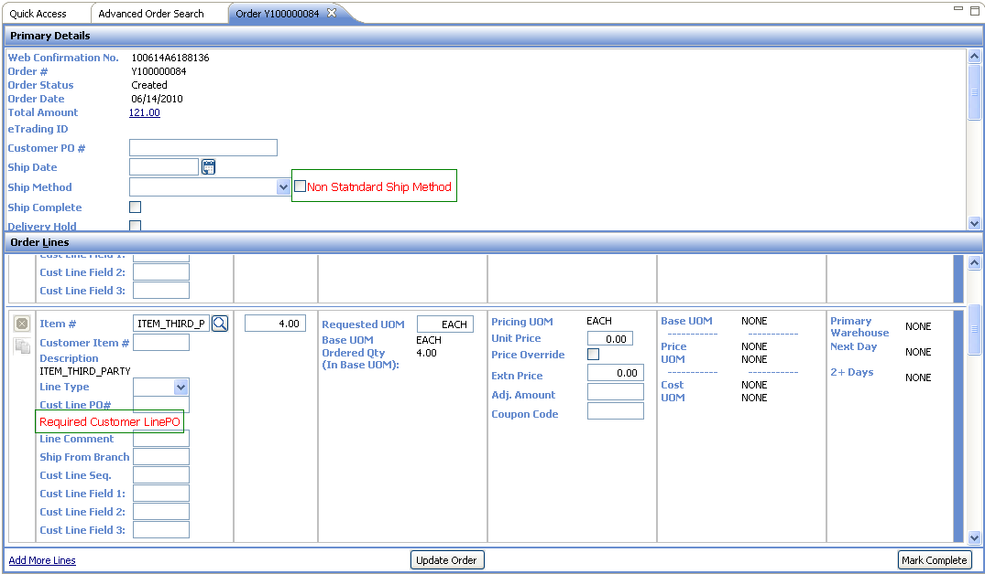

Open Questions
N/A

Assumptions
- Sterling will track audits on an order only after the order confirmation number is generated.
- If CSR queries the Sterling system using the Call Center, the list of orders visible to him will depend on his division assignment.
- xpedx will maintain an accurate item cost in the legacy systems.
- Orders to go on Hold if the P&A service is down during order placement with a note indicating the order was put on hold because P&A service was down at the time of order placement, CSR to review the held order and manually reprocess it.
- Each customer will have their own definition of STANDARD shipping method.
- All rules which have a value of Hold in the Web Channel column indicate that the rule will be enforced in the Order Dashboard rules engine.
- Require customer line field <x> - for these rules to be enforced in the Web Channel UI, these fields should be enabled in the customer profile along with the corresponding rule.

Glossary

Term | Definition
CSR | Customer Service Representative
P&A | Price and Availability

